**Employability Game Report - Persuasion**

The aim of the game is to convince the rest of the players that they should vote for your topic.

The only materials needed for the game was somewhere to log the points of all the players but also a wheel to randomly select the topics that two of the players will be arguing about.

The rules of the game were that two of the players would debate over two topics and the rest of the players had to decide which one they wanted to vote for.

And the game works as decribed in the screenshots below that were created in the games development.

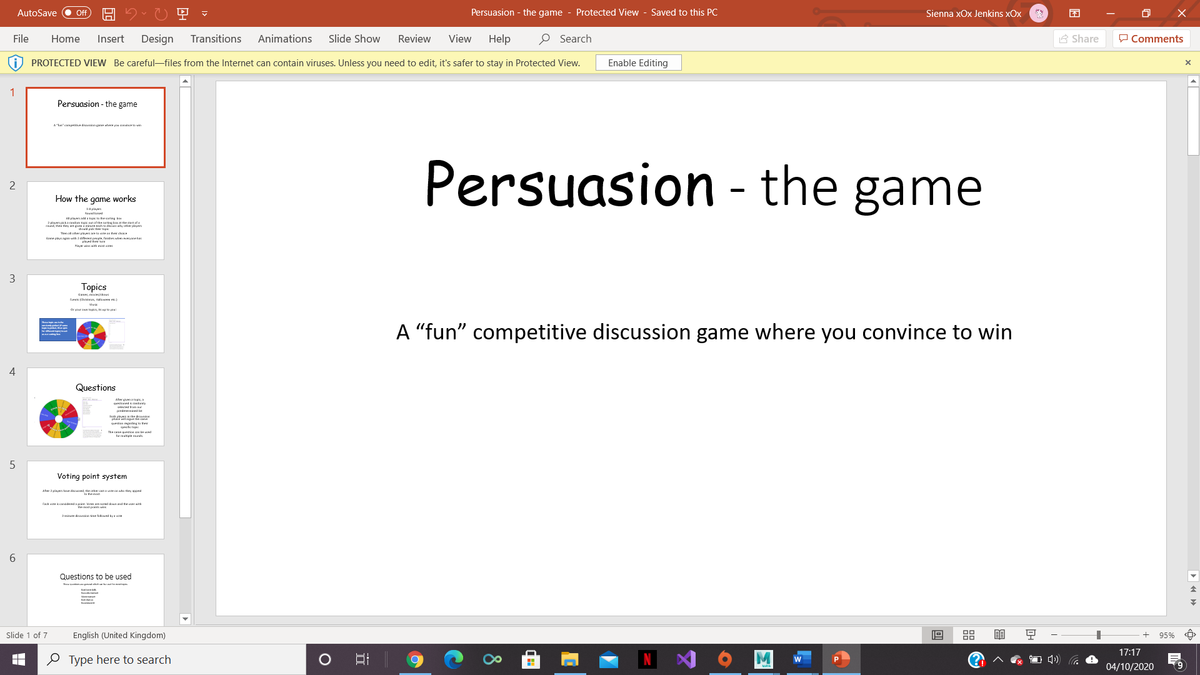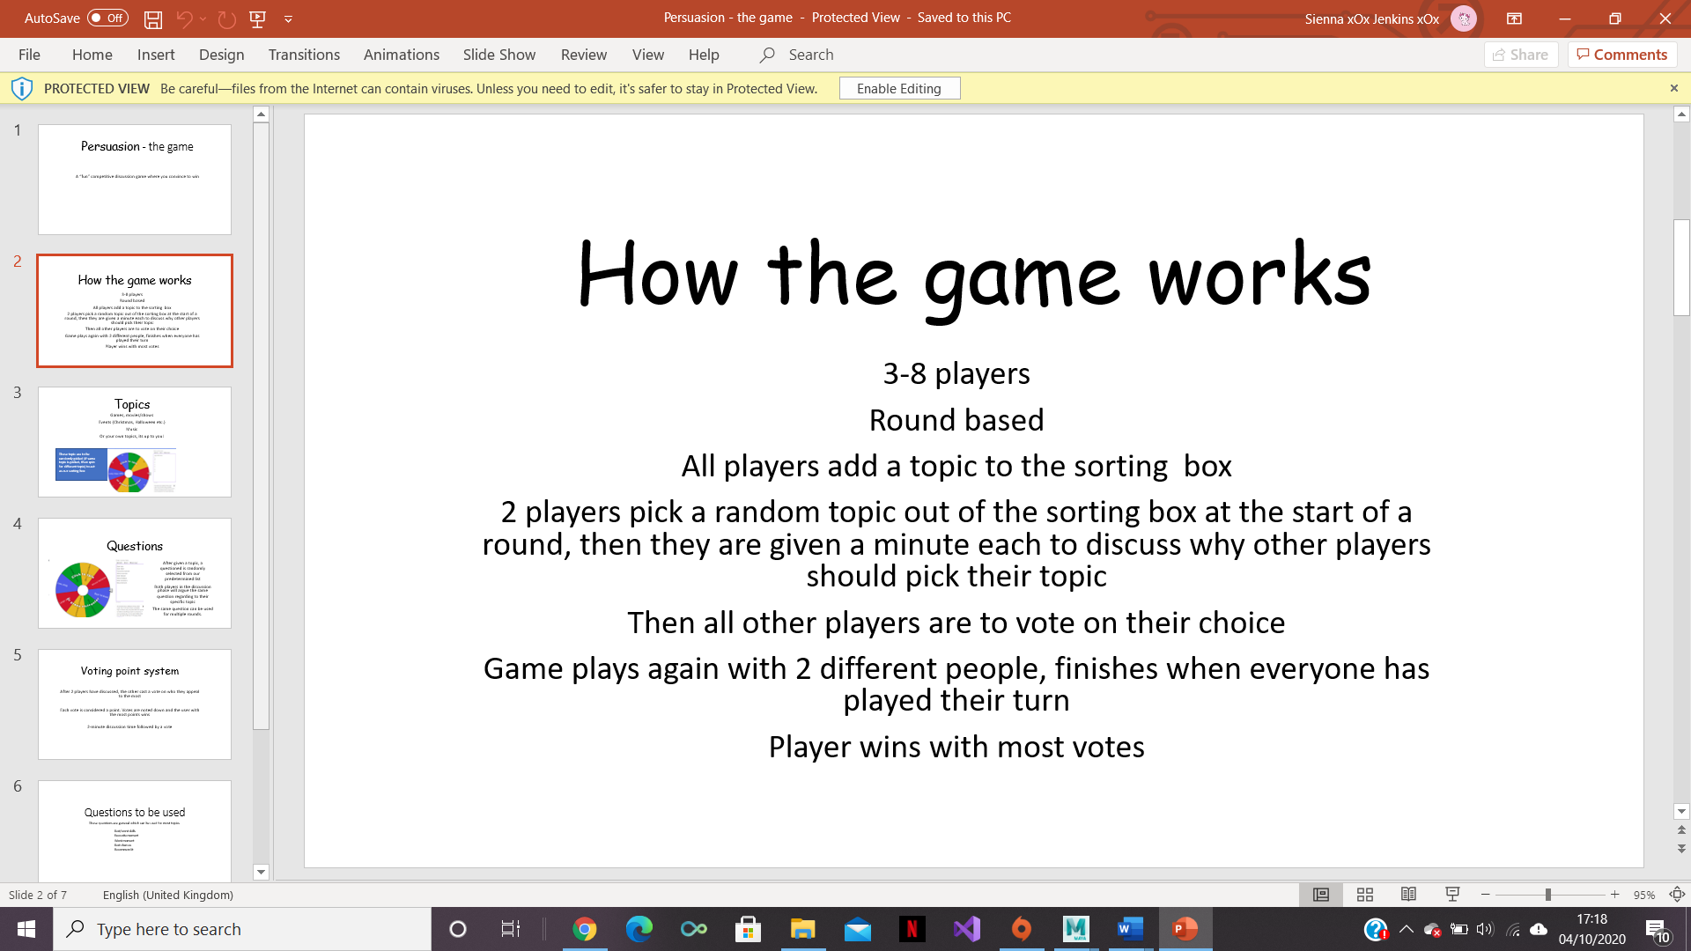

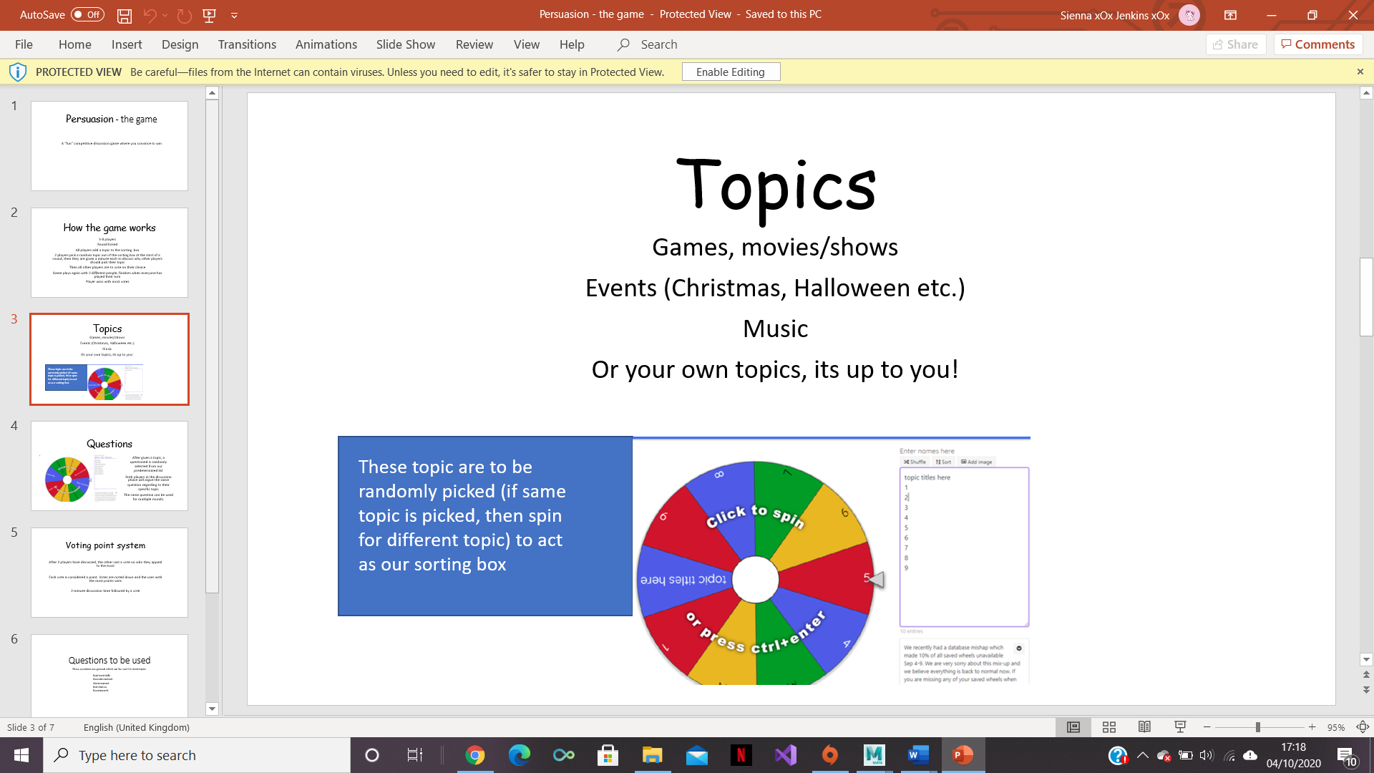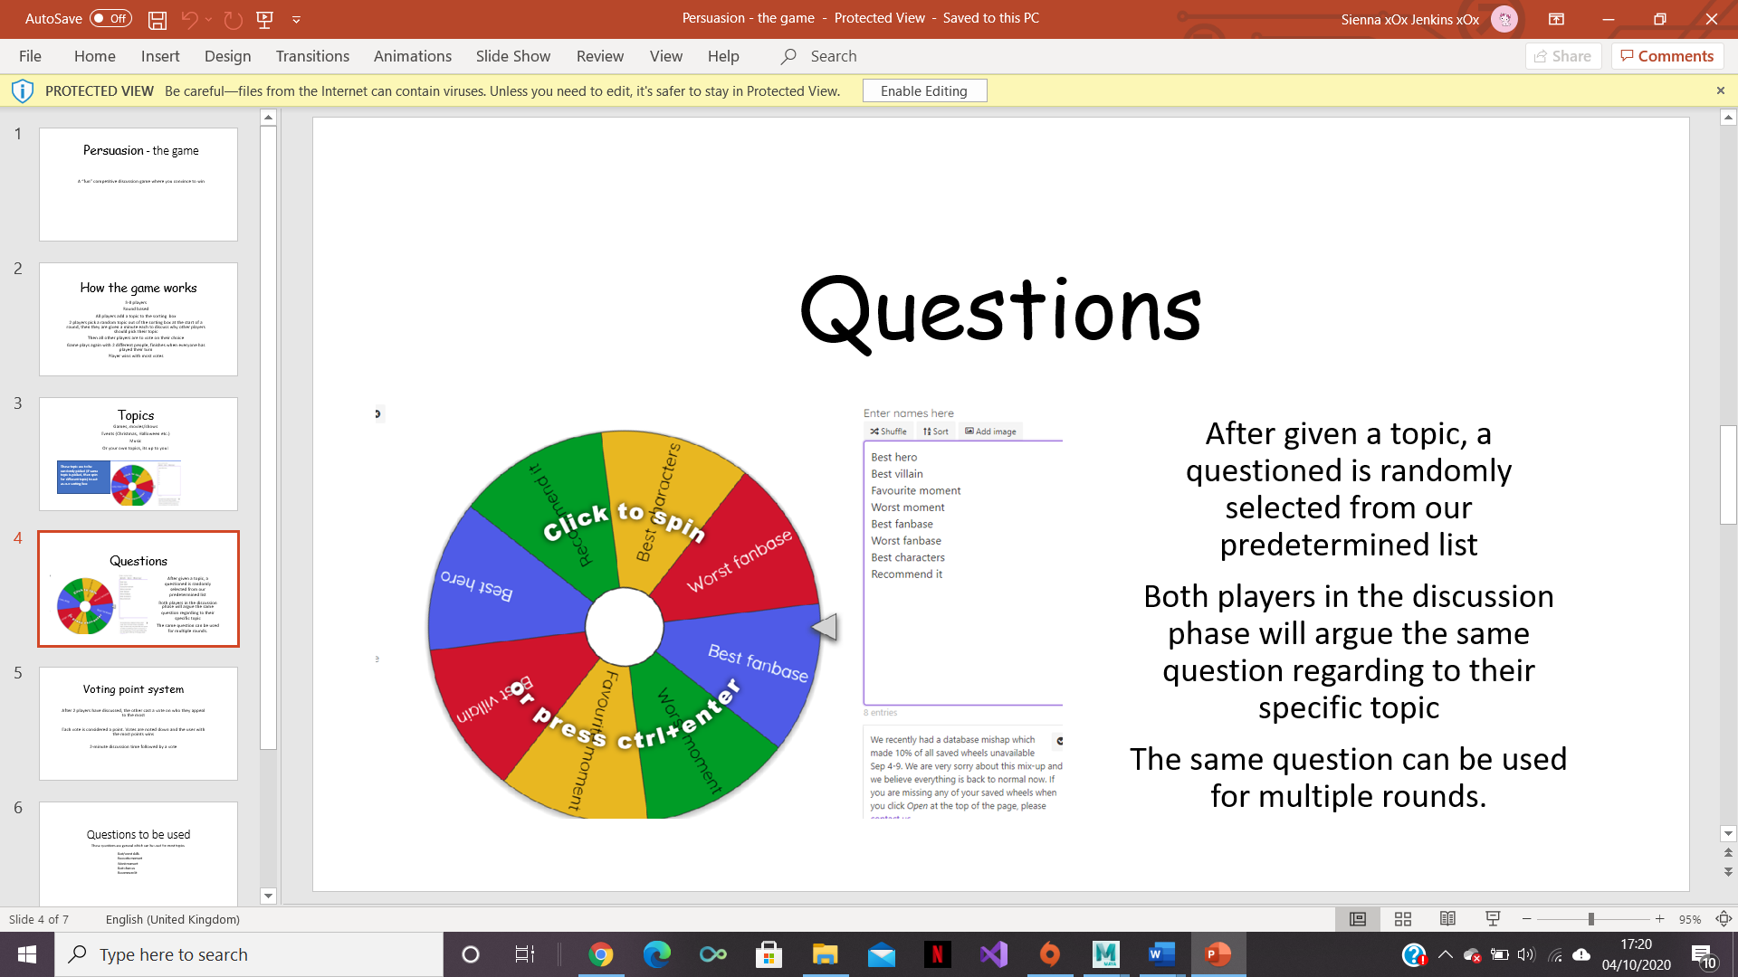

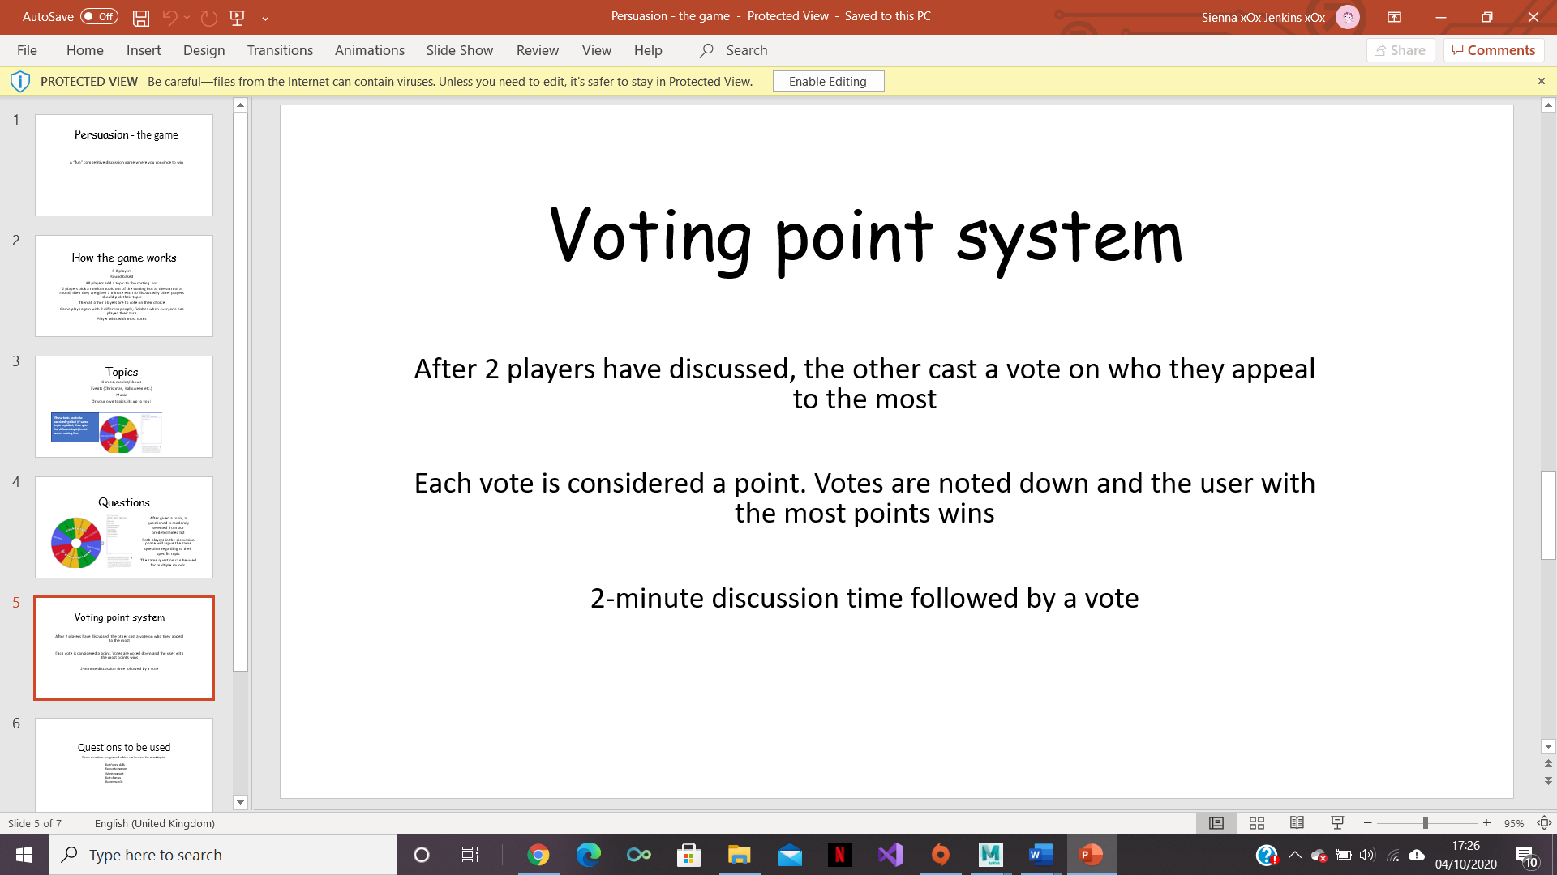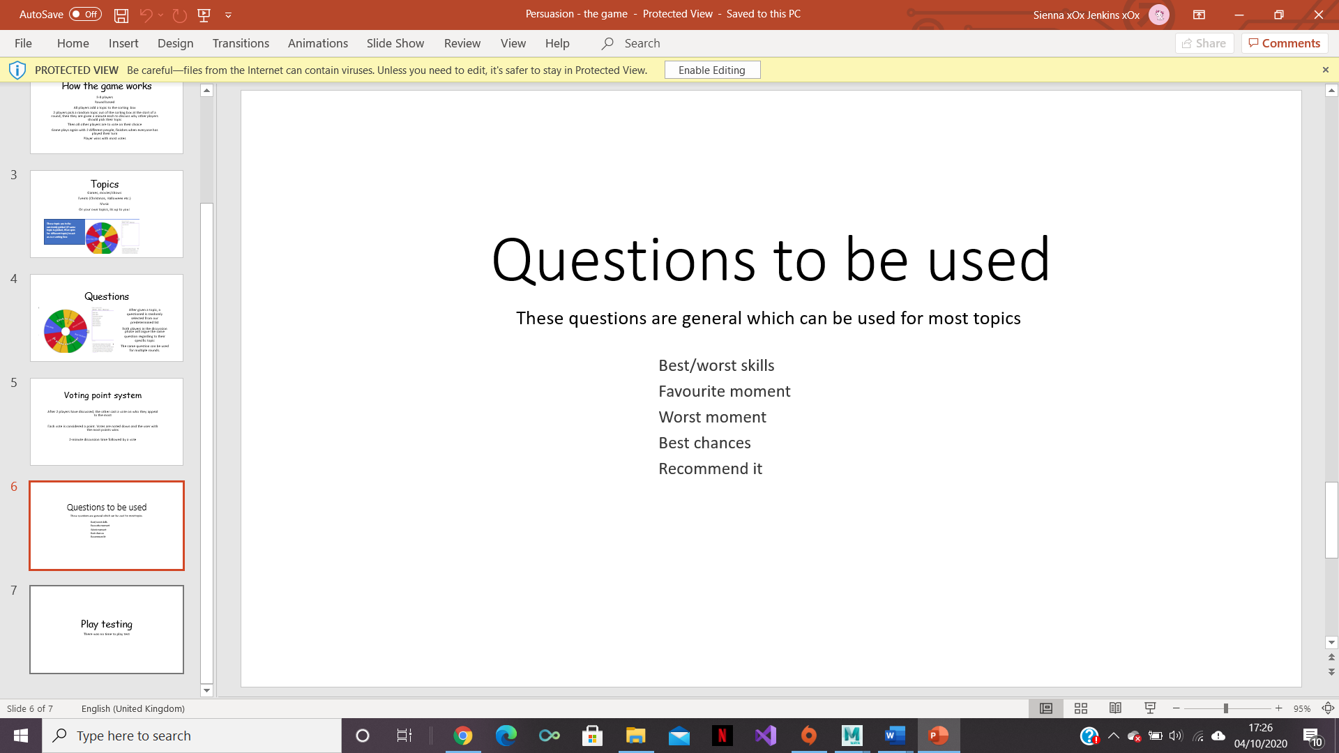

Unfortunately, the team didn’t have time to do any play testing so the game was unable to develop from this but would be a key part of development to get done in the future.

Working in a team was very easy and productive. Everyone shared ideas and there was no conflict about how the game should work, and everyone got on. Being able to work in a team like that is very important for employability as in most jobs, they require you to work in teams and be able to get along with co-workers. If you are unable to work in a team, employers will be less likely to hire you as they would feel that you wouldn’t be able to get on with co-workers and wouldn’t participate in jobs that were not able to be done alone.

From this assignment, there were some other key skills that were learnt for good employability. For example, in the game it is about persuading the other players to vote for you which feeds into skills of persuading an employer to hire you. Also, it taught the players how to compete with other people who could also being applying for the same job.

As previously mentioned, next time it would be a good idea to do some play testing even if it’s just testing with the game designers and not using external play testers. This is because it would check that the game functions properly and there are no holes in how the game works.

Names of the game designers –

Sienna Jenkins

Zakaria Ahmed

And Joshua Baker.

There were no play testers.